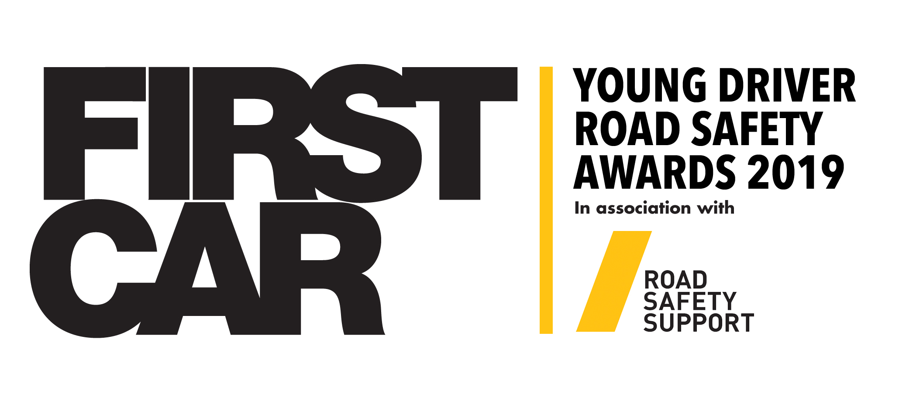

Name of scheme/initiative/individual:

Contact name:
Position:
Organisation:
Telephone number: ‬
Email address:

25-word award entry synopsis:

Supporting logo (high resolution 300dpi) to be attached with entry:

This year, we are welcoming nominations for six categories; New Scheme, Education and Training Initiative, Partnership Scheme, Young Driver Marketing Campaign and Private Sector Initiative. Entries will be judged on the below criteria, with the judging panel placing the entry into the most relevant category.

The Lifetime Achievement Award - will be judged against different criteria to the above. We are looking for nominations for people who has gone above and beyond the call of duty to help improve young driver safety. Someone who has worked tirelessly, unselfishly, often unnoticed, over the years to make a real positive difference. Impressive commitment, leadership, skill, personality, empathy… the vision to make a difference… an unnerving desire to positively influence when others may throw in the towel. Tell us about the nominee – their name, company, position and career details as far as you know and your connection to the nominee.

Submissions are limited to 1,000 words, with a maximum of three single page supporting documents. Each entry will be judged on the bullet points listed below on a scale of 0-10. No evidence scores zero, very strong evidence scores the maximum ten points.

- has a data-driven evidence of need
- evidence that it is based on a sound conceptual framework (theory of behaviour change) or established schemes that have demonstrated success
- has been pre-tested through a pilot scheme
- is clearly and specifically targeting the young driver
- has clear and measurable aims and objectives
- shows innovation
- properly evaluated, be that preliminary, current and/or historical evaluation
- has made a real difference, with supporting evidence, to improving young driver behaviour
- overall feel of initiative, including take up with target market

1,000-word submission:

